CSCI 4370 Project 4 Report

**Team:** 2019NationalChamps

**Team Members:** Alex Kimbrell (ER Diagram), Pravallika Nallamotu (3NF), Obediah Blair (BCNF)

|  |  |  |  |
| --- | --- | --- | --- |
|  | ER | BCNF | 3NF |
| No. of tables | 6 | 8 | 6 |
| Lossless | Yes | Yes | Yes |
| Functional Dependencies Preserved | Yes | Yes | Yes |

ER Diagram:

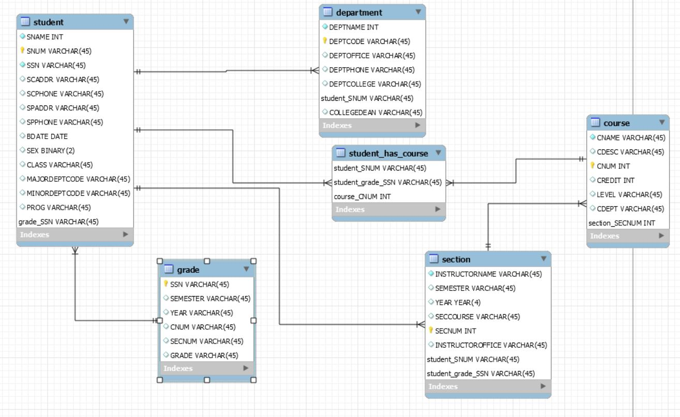

Above is a visual representation of the schema for the university database. The database initially contained 5 tables (student, department, course, section, and grade), but an additional tables was added when forming relationships between tables. The student_has_course table was automatically added by MySQL Workbench since the student table and the course table have a many-to-many relationship (a student can take multiple courses, and a course can have multiple students). Other relationships are also present in the diagram. For instance, student and grade have a one-to-many relationship since a student can have multiple grades, but each grade only corresponds to one student.

BCNF:

* To satisfy BCNF the table:
  + Should be in 3NF
  + And, for any dependency A → B, A should be a **super key**
* After the 3NF synthesis, I was unable to find any violations for BCNF that would require any further changes to the tables. From checking Piazza, I found that other students had similar issues, so Dr. Arpinar added some new attributes to the description in order to combat them.
* From the Piazza post, I’ve added the attribute COLLEGEDEAN to the ‘department’ table and INSTRUCTOROFFICE to the ‘section’ table in our 3NF synthesized database.
* ‘Department table’ changes:
  + DEPTCODE, COLLEGEDEAN form a primary key because you can find all the columns in the table with this combination
  + COLLEGEDEAN depends on DEPTCOLLEGE, which is not allowed in BCNF
  + because DEPTCOLLEGE is not a super key in this instance
  + We create new table ‘college’ in order to satisfy BCNF
* ‘Section table’ changes:
  + SECNUM,INSTRUCTOROFFICE form a primary key because you can find all the columns in the table with this combination.
  + INSTRUCTOROFFICE depends on INSTNAME, and this is not allowed because INSTNAME is not a super key in this instance
  + We create a new table ‘instructor’ in order to satisfy BCNF
* New tables ‘college’ and ‘instructor’ are in bcnf.sql

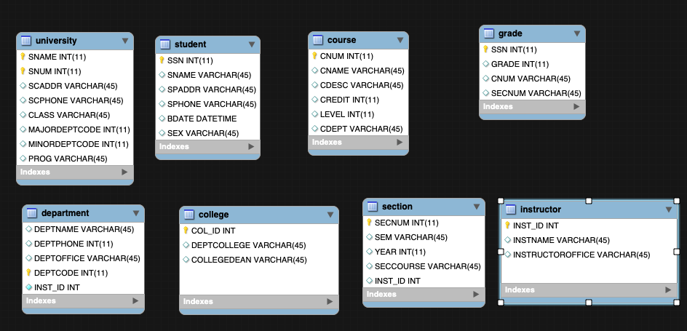

3NF:

* The yellow highlighted values are the keys (multiple primary keys make up the Candidate Key)
* There are example records in each table

**Comparison Table**

* No of Tables: 6
* Lossless: Yes
* FD Preserved: Yes

**1NF Synthesis**

* To put the tables in 1NF I ensured:
  + Each record is unique
  + Each cell contains a single value
* I had to split up the CNUM,SECNUM column in Grades table into two separate columns because there should only be a single atomic entry

**University Table:**

|  |  |  |  |  |  |  |  |  |  |  |  |  |
| --- | --- | --- | --- | --- | --- | --- | --- | --- | --- | --- | --- | --- |
| SNAME | SNUM | SSN | SCADDR | SCPHONE | SPADDR | SPHONE | BDATE | SEX | CLASS | MAJORDEPTCODE | MINORDEPTCODE | PROG |
| Patrick | 1 | 765 | Miller st | 543546546 | Hew Dr | 543546546 | 01.01.1994 | M | Soph | 321 | 243 | BS |
| Mary | 2 | 654 | Miller st | 5675465434 | Block St | 5675465434 | 02.02.1994 | F | Junior | 243 | 321 | BS |
| Tim | 3 | 354 | Test Dr | 6787654564 | Wire St | 6787654564 | 03.03.1994 | M | Graduate | 245 | 245 | BA |

**Department Table:**

|  |  |  |  |  |
| --- | --- | --- | --- | --- |
| DEPTNAME | DEPTCODE | DEPTPHONE | DEPTOFFICE | DEPTCOLLEGE |
| Math | 321 | 6789304958 | 326 | College of Arts |
| English | 243 | 6839485789 | 265 | College of Arts |
| Biology | 245 | 5792837485 | 264 | College of Science |

**Course Table:**

|  |  |  |  |  |  |
| --- | --- | --- | --- | --- | --- |
| CNAME | CDESC | CNUM | CREDIT | LEVEL | CDEPT |
| MATH1113 | A beginner course to algebra | 352 | 4 | 1000 | Math |
| ENGL1102 | A class on Edgar Allen Poe works | 285 | 3 | 1000 | English |
| BIOL1104 | Beginner Bio class on Living Organisms | 948 | 4 | 1000 | Biology |

**Section Table:**

|  |  |  |  |  |
| --- | --- | --- | --- | --- |
| INST NAME | SEM | YEAR | SEC COURSE | SEC NUM |
| Edgar Poe | FALL | 2019 | ENGL1102 | 1 |
| Eliza Allen | FALL | 2019 | BIOL1104 | 2 |
| Sarah Cooke | SP | 2019 | MATH1113 | 3 |

**Grade Table:**

|  |  |  |  |  |  |
| --- | --- | --- | --- | --- | --- |
| SSN | SEMESTER | YEAR | CNUM | SECNUM | GRADE |
| 765 | FALL | 2019 | 352 | 1 | B |
| 654 | FALL | 2019 | 285 | 2 | B |
| 354 | SPRING | 2019 | 948 | 3 | A |

**2NF Synthesis**

* To put the tables in 2NF I ensured:
  + That I removed all partial dependencies – meaning any column not reliant on both columns in the composite key should be separated
  + I separated the University table into two separate tables to avoid trivial functional dependencies
  + I created a new Student table containing all columns relevant to their SSN number (the primary key)

**University Table:**

|  |  |  |  |  |  |  |  |
| --- | --- | --- | --- | --- | --- | --- | --- |
| SNAME | SNUM | SCADDR | SCPHONE | CLASS | MAJORDEPTCODE | MINORDEPTCODE | PROG |
| Patrick | 1 | Miller st | 543546546 | Soph | 321 | 1A | BS |
| Mary | 2 | Miller st | 5675465434 | Junior | 243 | NA | BS |
| Tim | 3 | Test Dr | 6787654564 | Graduate | 245 | 3A | BA |

**Student Table**

|  |  |  |  |  |  |
| --- | --- | --- | --- | --- | --- |
| SNAME | SSN | SPADDR | SPHONE | BDATE | SEX |
| Patrick | 765 | Hew Dr | 543546546 | 01.01.1994 | M |
| Mary | 654 | Block St | 5675465434 | 02.02.1994 | F |
| Tim | 354 | Wire St | 6787654564 | 03.03.1994 | M |

**Department Table:**

|  |  |  |  |  |
| --- | --- | --- | --- | --- |
| DEPTNAME | DEPTCODE | DEPTPHONE | DEPTOFFICE | DEPTCOLLEGE |
| Math | 321 | 6789304958 | 326 | College of Arts |
| English | 243 | 6839485789 | 265 | College of Arts |
| Biology | 245 | 5792837485 | 264 | College of Science |

**Course Table:**

|  |  |  |  |  |  |
| --- | --- | --- | --- | --- | --- |
| CNAME | CDESC | CNUM | CREDIT | LEVEL | CDEPT |
| MATH1113 | A beginner course to algebra | 352 | 4 | 1000 | Math |
| ENGL1102 | A class on Edgar Allen Poe works | 285 | 3 | 1000 | English |
| BIOL1104 | Beginner Bio class on Living Organisms | 948 | 4 | 1000 | Biology |

**Section Table:**

|  |  |  |  |  |
| --- | --- | --- | --- | --- |
| INST NAME | SEM | YEAR | SEC COURSE | SEC NUM |
| Edgar Poe | FALL | 2019 | ENGL1102 | 1 |
| Eliza Allen | FALL | 2019 | BIOL1104 | 2 |
| Sarah Cooke | SP | 2019 | MATH1113 | 3 |

**Grade Table:**

|  |  |  |  |  |  |
| --- | --- | --- | --- | --- | --- |
| SSN | SEMESTER | YEAR | CNUM | SECNUM | GRADE |
| 765 | FALL | 2019 | 352 | 1 | B |
| 654 | FALL | 2019 | 285 | 2 | B |
| 354 | SPRING | 2019 | 948 | 3 | A |

**3NF Synthesis**

* To put the tables in 3NF I ensured:
  + All transitive functional dependencies are removed
  + Transitive dependencies are when a non-key attribute is dependent on another non-key attribute
  + The TD in this database are highlighted in green. They are considered redundant and will be removed.

**University Table:**

|  |  |  |  |  |  |  |  |
| --- | --- | --- | --- | --- | --- | --- | --- |
| SNAME | SNUM | SCADDR | SCPHONE | CLASS | MAJORDEPTCODE | MINORDEPTCODE | PROG |
| Patrick | 1 | Miller st | 543546546 | Soph | 321 | 1A | BS |
| Mary | 2 | Miller st | 5675465434 | Junior | 243 | NA | BS |
| Tim | 3 | Test Dr | 6787654564 | Graduate | 245 | 3A | BA |

**Student Table**

|  |  |  |  |  |  |
| --- | --- | --- | --- | --- | --- |
| SNAME | SSN | SPADDR | SPHONE | BDATE | SEX |
| Patrick | 765 | Hew Dr | 543546546 | 01.01.1994 | M |
| Mary | 654 | Block St | 5675465434 | 02.02.1994 | F |
| Tim | 354 | Wire St | 6787654564 | 03.03.1994 | M |

**Department Table:**

|  |  |  |  |  |
| --- | --- | --- | --- | --- |
| DEPTNAME | DEPTCODE | DEPTPHONE | DEPTOFFICE | DEPTCOLLEGE |
| Math | 321 | 6789304958 | 326 | College of Arts |
| English | 243 | 6839485789 | 265 | College of Arts |
| Biology | 245 | 5792837485 | 264 | College of Science |

**Course Table:**

|  |  |  |  |  |  |
| --- | --- | --- | --- | --- | --- |
| CNAME | CDESC | CNUM | CREDIT | LEVEL | CDEPT |
| MATH1113 | A beginner course to algebra | 352 | 4 | 1000 | Math |
| ENGL1102 | A class on Edgar Allen Poe works | 285 | 3 | 1000 | English |
| BIOL1104 | Beginner Bio class on Living Organisms | 948 | 4 | 1000 | Biology |

**Section Table:**

|  |  |  |  |  |
| --- | --- | --- | --- | --- |
| INST NAME | SEM | YEAR | SEC COURSE | SEC NUM |
| Edgar Poe | FALL | 2019 | ENGL1102 | 1 |
| Eliza Allen | FALL | 2019 | BIOL1104 | 2 |
| Sarah Cooke | SP | 2019 | MATH1113 | 3 |

**Grade Table:**

|  |  |  |  |  |  |
| --- | --- | --- | --- | --- | --- |
| SSN | SEMESTER | YEAR | CNUM | SECNUM | GRADE |
| 765 | FALL | 2019 | 352 | 1 | B |
| 654 | FALL | 2019 | 285 | 2 | B |
| 354 | SPRING | 2019 | 948 | 3 | A |

Comparison of 3 Methods

The ER Diagram, BCNF decomposition, and 3NF synthesis all seek to help a database manager recognize and eliminate redundancy in his/her database design. The reduction of redundancy is critical for the overall performance of querying the database. Insertions, deletions, and updates to tables will be considerably better once a database schema has gone through BCNF or 3NF. In general, 3NF synthesis can typically be obtained without having to sacrifice functional dependencies and is lossless. BCNF decomposition does not necessarily preserve functional dependencies and can often result in lossy decomposition.